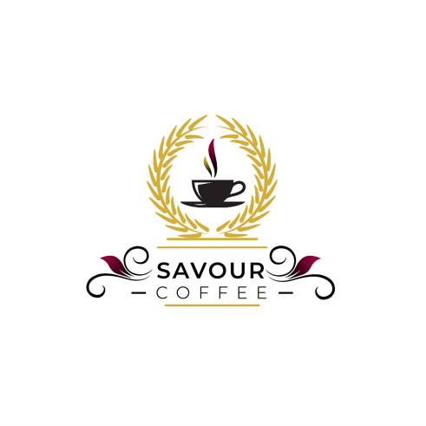

**FOR IMMEDIATE RELEASE**

**DOWNLOAD LINKS:** [**PHOTOS, LOGO**](https://prioritymarketing.sharefile.com/d-scf2cdd48e61044bdbab72d95f5a31435)

**Savour Coffee brews up excitement with grand opening celebration**

FORT MYERS, Fla. (Dec.1, 2023) - Savour Coffee, Southwest Florida's new and unique coffee shop, held its grand opening celebration recently and welcomed guests with an array of drinks and freshly made pastries.

Coffee enthusiasts, business leaders and area residents all joined owner Matt Geiger, his wife Mimi and the staff at Savour for a ribbon-cutting ceremony to celebrate the opening of Matt’s longtime dream. The distinctive layout, combining his catering business, Savour First Choice Catering, with his new coffee shop, gave guests a one-of-a-kind look “behind the scenes” of his catering kitchen. This design is one of the ways in which Savour Coffee is set apart from others in the area.

Matt expressed his gratitude for the warm reception and turnout from the community, stating, "We are thrilled to bring Savour Coffee to Fort Myers. Our passion for quality coffee and a welcoming atmosphere is reflected in everything we do. We look forward to becoming a valued spot for coffee lovers and a gathering place for friends and neighbors.”

Savour Coffee is located in the Island Park Shopping Center, 16520 S. Tamiami Trail #138, Fort Myers. It is open Monday-Friday, 7:30 a.m. - 3 p.m. and Saturday, 8:30 a.m. - 3 p.m. For more information about Savour Coffee, please visit [savourcoffee.com](http://savourcoffee.com/) or call 239-351-5547.

**ABOUT SAVOUR COFFEE**

Savour Coffee was started thanks to the passion of its owner Chef Matt Geiger. After years of working in restaurants, cafes and opening his own catering company, it was time to take an early passion of his and make it a reality. Savour Coffee was brought to life when Geiger was building his new catering facility. Using locally roasted coffee that’s delivered weekly, combined with his twist on familiar menu items featuring breakfast, lunch and pastry options he was able to compliment his specialty beverage menu of not only espresso drinks, but some creations of his own. For more information about Savour Coffee, please visit [savourcoffee.com](http://savourcoffee.com/) or call 239-351-5547.

**Captions for photos:**

(1) Matt and Mimi Geiger

(2) Steph Kinney, Lucy Moreira, Matt Geiger and Amanda Calvert

(3) Ribbon cutting at Savour Coffee

(4) Tara Settembre

(5) Aaron Greenfield

(6) Randy Mitchelson and Hallie Davis

(7) Rosie Ruano and Craig Hauble

(8) Matt Geiger and David Dorsey

(9) Mike Pruchnik and Alison Calder

(10) Christine Cottone and Doug Donaldson

(11) Christian Anderson

(12) Craig Trapani and Ian Ackerman

- END -

**Media Contacts:**

Holly Boldrin, APR, CPRC, Priority Marketing, [Holly@PriorityMarketing.com](mailto:Holly@PriorityMarketing.com), 239-267-2638 or 239-887-9335 (cell)

Josh Milton, Priority Marketing, [Josh@PriorityMarketing.com,](mailto:Josh@PriorityMarketing.com) 239-267-2638 or 518-338-5114 (cell)