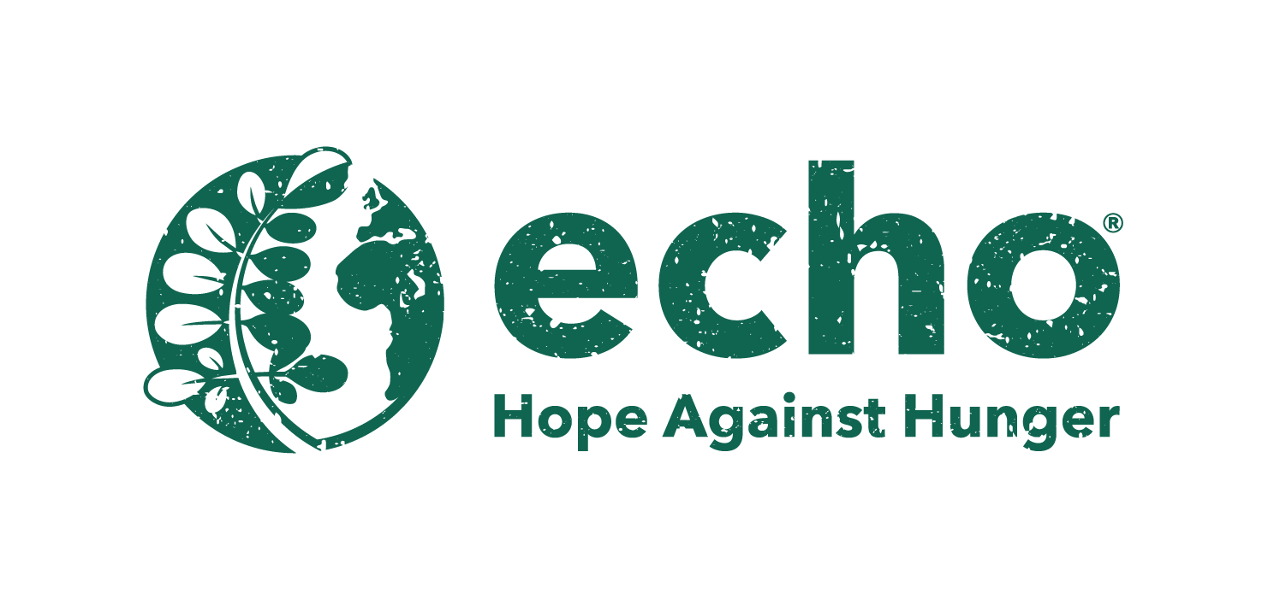

**FOR IMMEDIATE RELEASE**

**DOWNLOAD LINKS:** [**PHOTOS, LOGO**](https://prioritymarketing.sharefile.com/d-s46d494e506a74607a9b28cbeac09185b)

**ECHO hosts delegates from 25 countries at international agriculture conference**

*Nearly 200 people from around the world attended three-day event*

FORT MYERS, Fla. (Nov. 13, 2023) - ECHO, Inc., a leading nonprofit global development organization, recently welcomed 190 delegates from 25 countries around the world to its North American Regional Impact Center in Southwest Florida for a three-day international conference devoted to eradicating hunger and improving lives through agriculture, clean water and community development.

#### Dozens of breakout sessions and workshops were held over the three-day event from Nov. 7-9. Topics included sustainable farming, plant grafting, natural farming, mobilizing churches for agricultural ministry, building resilience against hunger through animal agriculture and many more.

Delegates left the conference with a great deal of information that will be taken back to their countries and used for improving the lives of millions of people around the world facing food insecurity daily.

Delegate Matthew Atokple, from Ghana, talked about the importance of attending this conference. “In Ghana we are into growing vegetables, but the gospel component, which is that holistic lifestyle, where we don't just need food to eat but we need to relate to the soil and plants, is very key, but we haven’t always paid much attention to that. Here at the conference, we are made aware of the impact this has on people in terms of development and transformation and the change of mindset.”

“We’ve been doing this conference for 30 years,” said ECHO CEO Dr. Abram Bicksler. “It’s all about connecting. Connecting people to each other, connecting people to ECHO and connecting people to strategies and ideas that they can use to bless the poor, improve the lives of individual farmers, families and communities. We’re hosting these events around the world. We have about 19,000 members that are formally connected to ECHO in 109 countries. As we move forward with our five-year plan, we continue to connect the network and serve the network.”

Bicksler added that although ECHO continues to do great work around the globe, there is still a great need. He said the statistics show there are about 793 million hungry people in the world and 44 million in the United States alone.

For more information about ECHO and how to support its mission, call 239-543-3246 or visit [ECHOnet.org](http://echonet.org/) or [ECHOcommunity.org](http://echocommunity.org/).

**ABOUT ECHO**

ECHO provides hope against hunger around the globe through agricultural training and resources. A Christian technical networking and resourcing organization, ECHO builds a network and serves that network by sharing validated contextualized agricultural options with technical excellence. ECHO’s goal is to serve its network members to advance food security and sustainable livelihoods. ECHO’s North American Regional Impact Center is located in Fort Myers, Fla. For more information about ECHO call 239-543-3246 or visit [ECHOnet.org](http://echonet.org/) or [ECHOcommunity.org](http://echocommunity.org/).

**Captions for photos:**

(1) ECHO delegates listen to Dr. Bill Price speak at the International Conference

(2) ECHO delegates listen to Dr. Bill Price speak at the International Conference

(3) ECHO delegates attend a workshop with Dr. Romina Gazis at the International Conference

(4) ECHO delegates attend a workshop with Dr. Romina Gazis at the International Conference

(5) ECHO delegates attend a workshop with Philip Deal at the International Conference

(6) ECHO delegates attend a workshop with Philip Deal at the International Conference

**- END -**

**Media Contacts:**

Holly Boldrin, APR, CPRC, Priority Marketing, [Holly@PriorityMarketing.com](mailto:Holly@PriorityMarketing.com), 239-267-2638 or 239-887-9335 (cell)

Josh Milton, Priority Marketing, [Josh@PriorityMarketing.com](mailto:Josh@PriorityMarketing.com), 239-267-2638 or 518-338-5114 (cell)