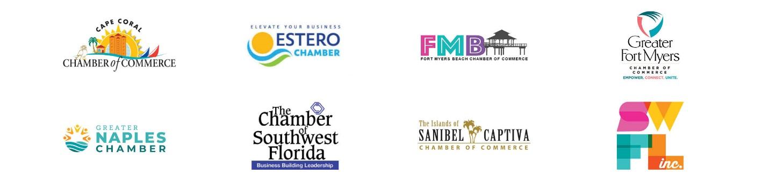

2022 Combined Legislative Priorities

Water Quality

We support consistent sustained funding levels for priority Everglades Restoration projects including the Everglades Agricultural Area reservoir to accomplish the objective of sending clean water south as quickly as possible; the C-43 Reservoir project and associated water quality treatment along the Caloosahatchee; and implementation of other critical storage and water quality infrastructure projects north, south, east, and west of Lake Okeechobee.

We support legislative actions implementing the Blue-Green Algae Task Force’s recommendations that aim to reduce nutrient pollution from all sources, to protect the public, businesses, and the environment from harmful algal blooms.

We support strengthening stormwater standards for urban landscapes (statewide stormwater rule update and ratification) and agricultural runoff, particularly for nutrient pollution from nitrogen and phosphorus that feeds harmful algal blooms.

We support funding for and plans to upgrade and build advanced wastewater treatment to reduce nutrients in reuse/reclaimed irrigation water with monitoring of nutrient concentrations.

We support the establishment of statewide septic tank inspection and maintenance requirements.

Tourism / Visit Florida
We support the continued full funding of Visit Florida based on the agency requested appropriations and the removal of the sunset clause.

Early childhood education-
We support initiatives that incentivize child care providers to offer infant care and nontraditional hours to better serve Florida’s workforce; encourage, promote and incentivize at-home providers to become registered childcare providers; and expand access to high-quality, affordable childcare options in Southwest Florida and across the state.

Collier County Veterans’ nursing home-
We support Collier County’s request to build a state veterans’ nursing home on County-owned property, located near Golden Gate Parkway and Collier Blvd., and to contribute $30 million in local option sales surtax revenue toward the State’s share of construction costs. We also support Collier County’s request for $14 million in operational and maintenance costs for each of the first two years of operations, until the facility census is at or near capacity and financially self-sustaining.

Workforce Development/ Education
We support fully funding workforce education programs provided by the state technical college system. We also support legislation that expands, encourages, and incentivizes work-based learning opportunities, including career and technical training, internships and apprenticeships, and post-secondary education.
We support funding for innovative and swift solutions that provide trained workers for in-demand industries.
We support creating alternative, non-traditional pathways to train an ever-evolving workforce.
We support fully funding career technical education programs.

Workforce Housing
We support policies that encourage and enable workforce/affordable housing opportunities including high-density mixed-use development.
We support policies that enable municipalities to be flexible with zoning and permitting processes; policies that cut red tape, eliminate government interference, and reduce building costs.
We support funding for local projects that provide affordable housing for the Southwest Florida workforce.
We support both public and private initiatives that offer incentives for planning and building workforce housing projects.
We support the creation of alternative funding solutions for workforce/affordable housing such as community development corporations or community land trusts.

