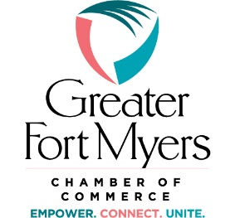

2020 Legislative Priorities
Visit Florida
The Greater Fort Myers Chamber of Commerce supports the growth of business for its members and community and believes that Visit Florida promotes long term growth for the state of Florida and the invaluable tourism industry.
Visit Florida provides Cooperative opportunities and Marketing partnerships to our community that would not be possible without their assistance.
The Greater Fort Myers Chamber of Commerce supports the continued full funding of Visit Florida based on the agency requested appropriations.

2021 Water Quality Legislative Priorities
• We support consistent sustained funding levels for priority Everglades Restoration projects including the Everglades Agricultural Area reservoir to accomplish the objective of sending clean water south as quickly as possible; the C-43 Reservoir project and associated water quality treatment along the Caloosahatchee; and implementation of other critical storage and water quality infrastructure projects north, south, east, and west of Lake Okeechobee.
• We support legislative actions implementing the Blue-Green Algae Task Force’s recommendations that aim to reduce nutrient pollution from all sources, in order to protect the public, businesses, and the environment from harmful algal blooms.
• We support strengthening stormwater standards for urban landscapes and agricultural runoff, particularly for nutrient pollution from nitrogen and phosphorus that feeds harmful algal blooms.
• We support funding for and plans to upgrade and build advanced wastewater treatment to reduce nutrients in reuse/reclaimed irrigation water with monitoring of nutrient concentrations.
• We support the establishment of statewide septic tank inspection and maintenance requirements.

